12401 Alder Woods Dr.
Fairfax, VA 22033
penderumc.org
703-278-8023

Please Join Us For These Fun Upcoming Events!

A Night in Bethlehem
Friday, December 13th
6pm – 8pm

This is a FREE family-friendly event! Invite your family and friends! Come to Bethlehem and see a night filled with light. Pender UMC is bringing the Christmas story to life so you and your family can walk through the Bethlehem marketplace and living nativity and be immersed in the spirit of Christmas. Visit and participate with Bethlehem bakers, carpenters, craftsmen, scribes and artists as you learn about the events surrounding Jesus’ birth, and see actors and live animals (including a camel!) in the nativity. No RSVP required.

Kick Off Your Winter Break With a Parents Night Out!
Friday, December 20th 5pm – 8pm

Drop off your children for a night of fun to kick off winter break while you enjoy a night out! All children who are walking up to 6th grade are welcome to attend. We will have fun games, a kid-friendly movie, storytelling and a yummy dinner.

Pricing: $25 for the first child, $10 for each additional child up to $50 max per family. Registration is required online as space is limited. Please visit http://pender.church/parentsnightout19 to register. (This is our first Night Out event – if it proves popular, we hope to offer it more frequently in 2020.) If you have any questions, please contact Jami Flemmons at jamiflemmons@verizon.net.

Gift Wrapping Available: Bring your gifts to be wrapped and we’ll take care of that for you. They will be wrapped and ready to go when you pick up your kiddos! Donations accepted.
Over
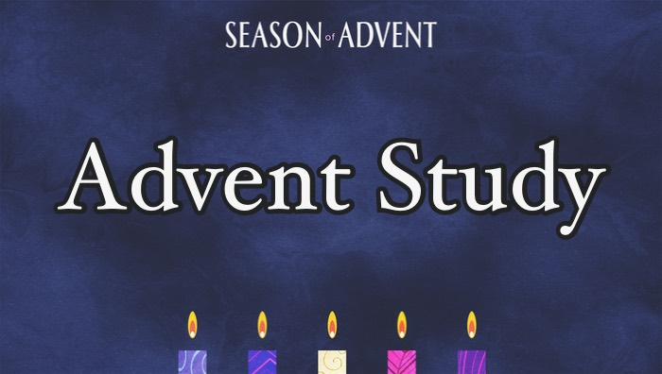
Advent Bible Study
Title – “Christmas – The Story You Thought You Knew”
Wednesdays Dec. 4, 11, & 18
at 9:45 am and 7 pm
Each session 60 minutes. Bible is our only text book for this one. So BYOB!

December 8th – One Service
Join us at 10:00am for our Christmas Cantata, “Night of the Father’s Love.”

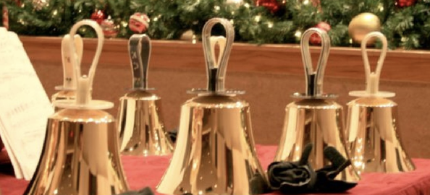
Carols, Cookies and Coffee
Handbell Concert
Join us at 5:00pm in the Sanctuary for an Amazing Christmas Handbell Concert, followed by cookies and coffee in the Fellowship Hall.
Christmas Eve Services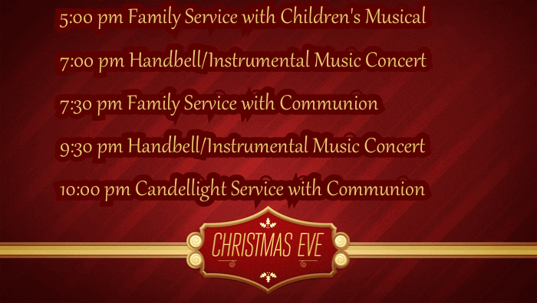
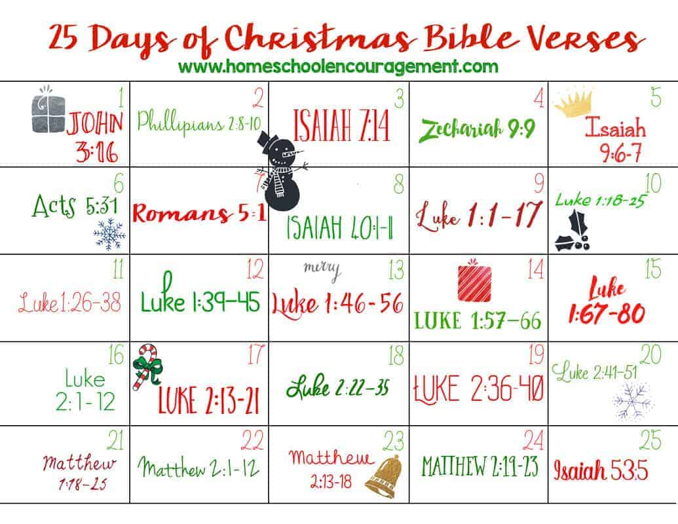

Celebrate Advent through acts of kindness!

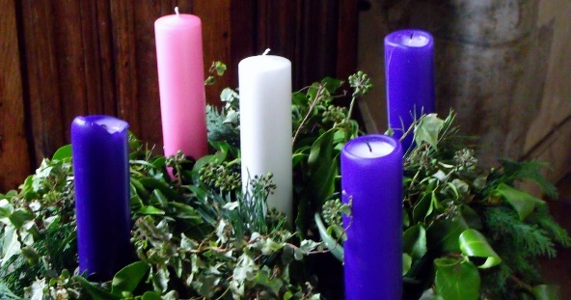

Join your Pender community in a big group effort to change the world and prepare for the birth of Jesus.

Follow us through the four phases of Advent
Hope, Love, Joy and Peace.

How can you be a part of the fun?

Starting December 1st:
1. Read a bible verse each day together.
2. Perform an act of kindness each day.
Ideas are included, but be creative!
3 Take turns applying a sticker to your nativity scene each day on the back of your Bible verse Calendar.
4. Check out Pender's Facebook page each day. Here you will see different friends reading the verse of the day and you can share your kindness experiences with the community.
